Experiment No 5
Aim : Study of Lexical analyzer tool -Flex/ Lex

Leraning Objective: Recognise lexical pattern from given input file

Theory:
Lex is a program generator designed for lexical processing of character input streams. It accepts a high-level, problem oriented specification for character string matching, and produces a program in a general purpose language which recognizes regular expressions. The regular expressions are specified by the user in the source specifications given to Lex. The Lex written code recognizes these expressions in an input stream and partitions the input stream into strings matching the expressions. At the boundaries between strings program sections provided by the user are executed. The Lex source file associates the regular expressions and the program fragments. As each expression appears in the input to the program written by Lex, the corresponding fragment is executed. The user supplies the additional code beyond expression matching needed to complete his tasks, possibly including code written by other generators. The program that recognizes the expressions is generated in the general purpose programming language employed for the user's program fragments. Thus, a high level expression language is provided to write the string expressions to be matched while the user's freedom to write actions is unimpaired. This avoids forcing the user who wishes to use a string manipulation language for input analysis to write processing programs in the same and often inappropriate string handling language.
Lex is not a complete language, but rather a generator representing a new language feature which can be added to different programming languages, called ``host languages.'' Just as general purpose languages can produce code to run on different computer hardware, Lex can write code in different host languages. The host language is used for the output code generated by Lex and also for the program fragments added by the user. Compatible runtime libraries for the different host languages are also provided. This makes Lex adaptable to different environments and different users. Lex itself exists on UNIX, GCOS, and OS/370; but the code generated by Lex may be taken anywhere where appropriate compilers exist.
Lex turns the user's expressions and actions (called source in this pic) into the host general-purpose language; the generated program is named yylex. The yylex program will recognize expressions in a stream (called input in this pic) and perform the specified actions for each expression as it is detected.
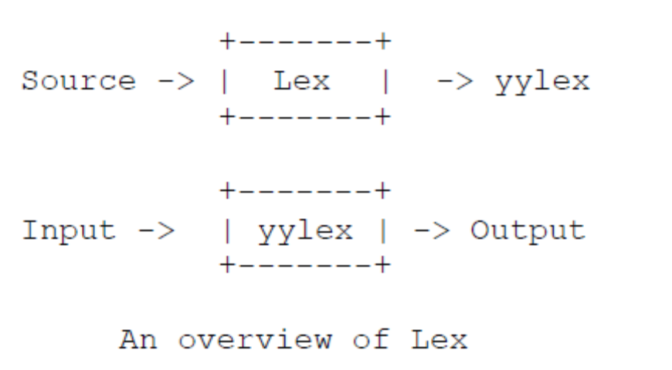

For a trivial example, consider a program to delete from the input all blanks or tabs at the
ends of lines.
%%
[ \t]+$ ;
is all that is required. The program contains a %% delimiter to mark the beginning of the rules, and one rule. This rule contains a regular expression which matches one or more instances of the characters blank or tab (written \t for visibility, in accordance with the C language convention) just prior to the end of a line. The brackets indicate the character class made of blank and tab; the + indicates ``one or more ...''; and the $ indicates ``end of line,'' as in QED. No action is specified, so the program generated by Lex (yylex) will ignore these characters. Everything else will be copied. To change any remaining string of blanks or tabs to a single blank, add another rule:
%%
[ \t]+$ ;
[ \t]+ printf(" ");
The finite automaton generated for this source will scan for both rules at once, observing at the termination of the string of blanks or tabs whether or not there is a newline character, and executing the desired rule action. The first rule matches all strings of blanks or tabs at the end of lines, and the second rule all remaining strings of blanks or tabs.
Lex can be used alone for simple transformations, or for analysis and statistics gathering on a lexical level. Lex can also be used with a parser generator to perform the lexical analysis phase.
The general format of Lex source is:
{definitions}
%%
{rules}
%%
{user subroutines}
where the definitions and the user subroutines are often omitted. The second %% is optional, but the first is required to mark the beginning of the rules. The absolute minimum Lex program is thus
%%
(no definitions, no rules) which translates into a program which copies the input to the output unchanged. In the outline of Lex programs shown above, the rules represent the user's control decisions; they are a table, in which the left column contains regular expressions and the right column contains actions, program fragments to be executed when the expressions are recognized. Thus an individual rule might appear integer printf("found keyword INT"); to look for the string integer in the input stream and print the message ``found keyword INT'' whenever it appears. In this example the host procedural language is C and the C library function printf is used to print the string. The end of the expression is indicated by the first blank or tab character. If the action is merely a single C expression, it can just be given on the right side of the line; if it is compound, or takes more than a line, it should be enclosed in braces.

Implementation Details:
1. Open file in text editor
2. Enter keywords, rules for identifier and constant, operators and relational operators. In
the following format
a) %{
Definition of constant /header files
%}
b) Regular Expressions
%%
Transition rules
%%
c) Auxiliary Procedure (main( ) function)
3. Save file with .l extension e.g. Mylex.l
4. Call lex tool on the terminal e.g. [root@localhost]# lex Mylex.l This lex tool will convert
“.l” file into “.c” language code file i.e. lex.yy.c
5. Compile the file lex.yy.c e.g. gcc lex.yy.c .After compiling the file lex.yy.c, this will
create the output file a.out
6. Run the file a.out e.g. ./a.out
7. Give input on the terminal to the a.out file upon processing output will be displayed
Test Cases:
- Input integer constant
- Input special symbols
Conclusion: Study of Lexical analyzer tool -Flex/ Lex has been completed.

